**1.Types of Applications:**Based the way of execution of program, all available applications are divided into two types.

1.1.Stand-alone Applications.

1.2. Enterprise Applicaitons

**1.1.Stand-alone Applications**:-The stand-alone application is developed using c,c++ ,core java or other programming language.Before using Stand alone application, we must install it in computer. It can only run in Installed computer. Only single user can access it at a time. We can’t access stand-alone application from remote machineeventhough remote machine and local system are in network..

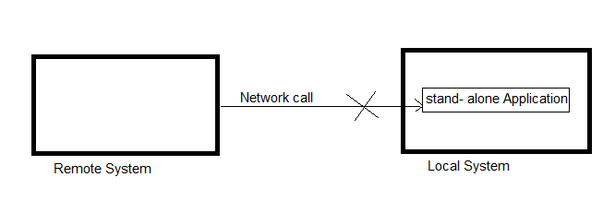

Example:

a.calculator ,VLC Media player ,Anti _virus software.

b. In our mobile and from play store, we download and install apps. All those apps are stand-alone applications.

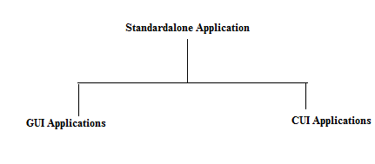

A.GUI Applications:- These application takes input from user through graphical Interfaces as well as displays output to user through graphical Interfaces.

🡪These applications can be ran from command prompt or using shortcut icons.some GUI applications can onlybe ran using web Browser.

Example : calculator ,…etc

CUI Applications:-The application which takes input from command prompt,displays output at command prompt and is executed from command prompt is called CUI application. The Command prompt is interface between user and application.It only supports character data.

Example: Usually student develop the java programs at lab. They are to be considered as CUI Applications.

**1.2. Enterprise Applications:-** The Enterprise application is web application , Distributed application and combination of web application and distributed application.

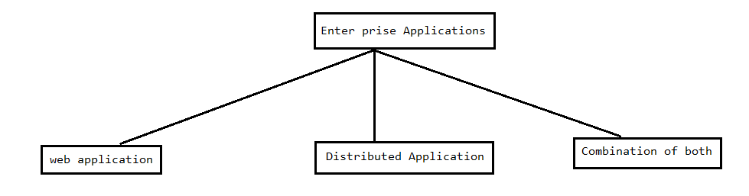

**1.2.1. Web Application**:- An Application that resides in server system and that is executed directly in server system via network call and sending response back to Client is called web application.

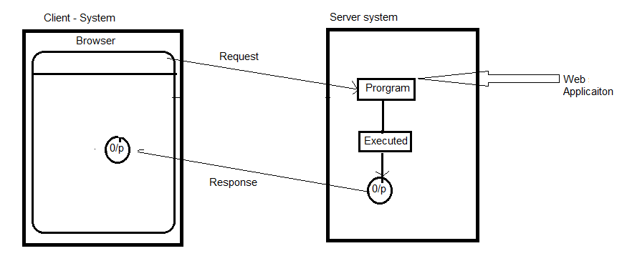

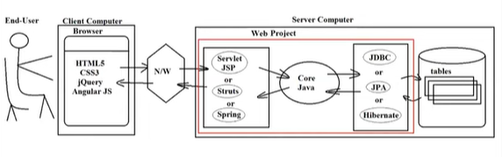

In above picture struts, spring, jpa and hibernate are frameworks not technologies.

**1.2.1.1**.**Web supportive Applications**:-The application which resides in server system , which come to client computer in response and which is downloaded and executed in client computer is called web supportive application.Using Applet technology, we develops the web supportive application. The web supportive application is part of web application.

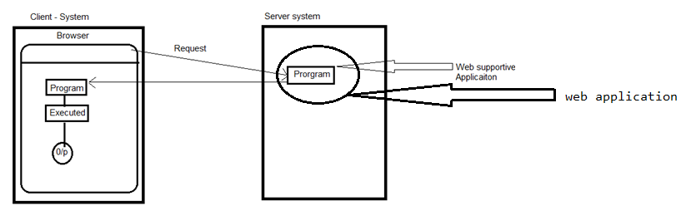

**1.2.2.Distributed Applications:-** An Application that resides in server system and that is executed directly in server system via network call and sending response back to Client is called Distributed applications.

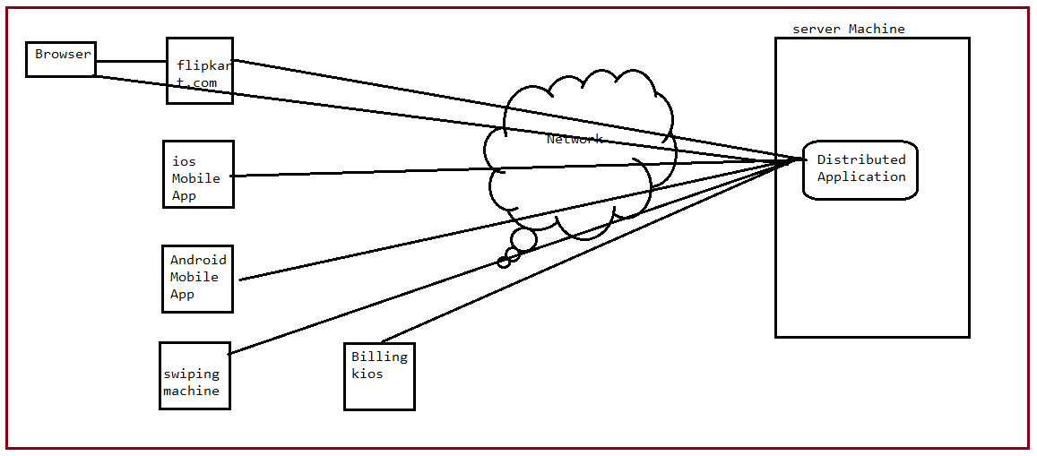

The Distributed application whose services can be accessed and used from different types of applications(clients) locally & remotely .

**1.2.3.Combination of Both:-** The third type of enterprise application is combination of web application and distributed application.

Example1:- Flipkart with cart payment/net banking facility is example to enterprise application.

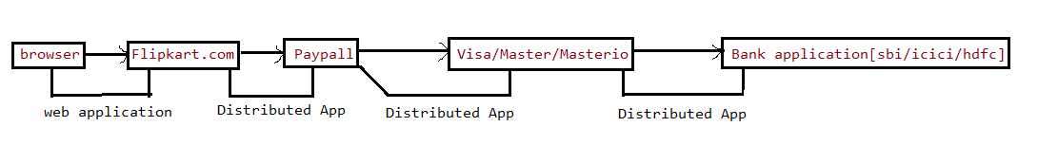

Example2:- Flipkart with UPI paymentility is example to enterprise application.

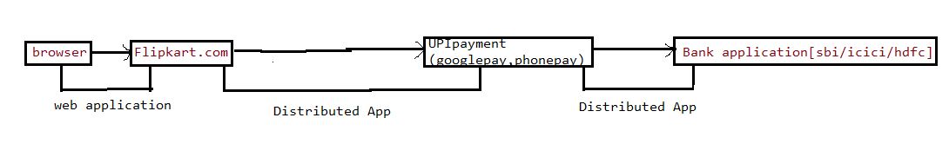

**2. Diff between Webapplication and Distributed Application.**

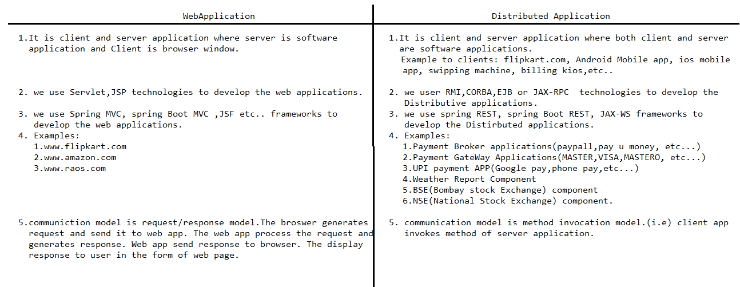

A typical application contains following logic:

1. Presentation Logic.
2. Service Logic/Business Logic
3. Persistence logic.

A.Presentation Logic:- The logic that gathers input from end user and show out put to end user is called presentation logic.

Example:-

a. System.out.println()

b. Forms.

c. Reports.

Etc …

B.Service Logic:- The logic that deals with filtering, calculation, analyzation, sorting and etc … is called service logic.

C.Persistence Logic:- The logic that interact with DB software for doing persistence operations is called persistence Logic.

**Example Application:-**

* **Read sno,sname,marks1,marks2,marks3 from end user |(Presentation logic)**
* **Calculate total & avg based on given marks and generate rank for the student.| (service logic)**
* **Store the sno,sname,mark1,marks2,marks3 , total , avg and rank in DB(Persistence logic)**
* **Display sno,sname,marks, total, avg & rank to end user|(Presentation logic).**